**check-Maximum-number-of-days-between-password-change**

NR

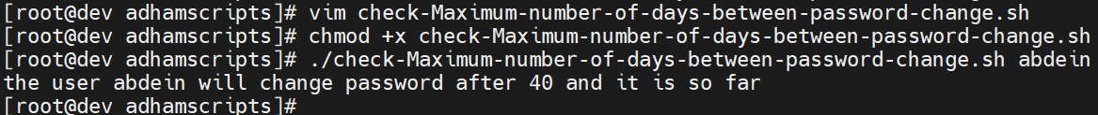

**change-Maximum-number-of-days-between-password-change**

